Case study – Designated Person for looked after children in Rumney Primary School, Cardiff

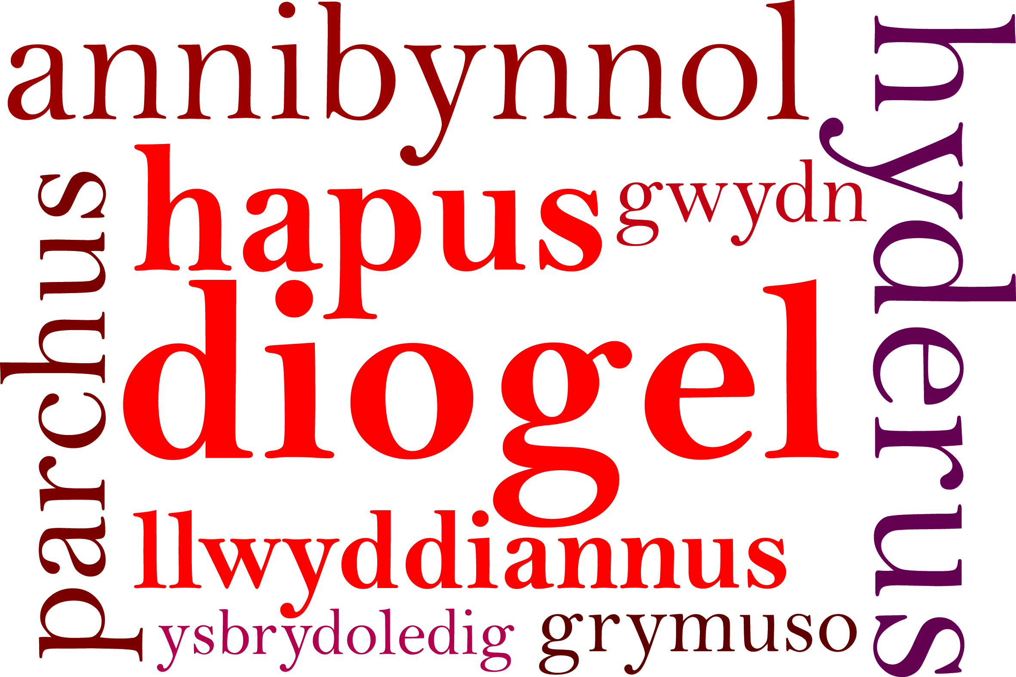

The Role of the Key Worker

Looked After Children often have a history of special people leaving them or losing contact with them. Many do not trust adults. When in care, many children have changes of foster carers and social workers.
Rumney Primary School may be the first place that provides a consistent, long term relationship with an adult who will focus on their personal, emotional and academic needs.
Many Looked After Children have significant periods of time when they have a great deal of uncertainty in their lives. Difficulties with relationships can trigger emotional trauma that may reveal itself through extreme behaviours or withdrawal.
For these children, knowing that someone genuinely cares about them is a significant factor in helping them regain a sense of trust.

The role
Our Key Workers:
- Know the children’s contexts, likes and dislikes, concerns, anxieties.
- Meet and greet at the start of each day, with a smile and mention of something from the previous day and a little commentary e.g. personal presentation.
- Have regular contact with the identified children to talk through any issues and concerns.
- Is someone who the child respects, trust and likes.
- Adopt a flexible approach to ensure opportunities for the child to have regular and easy contact. Some children need more support, whilst others need something that is more ‘light touch’.
- Are a ‘haven’; with whom someone to take time out, reflect and on some occasions calm down.
- Is a good, positive and consistent role model.
- Get to know the families and build a relationship with the children that is different from class teacher or that of the designated teacher for Looked After Children.
- Discuss actions and improve achievement.
- Keep on-going, open communication with other key adults in the school.
- Attend on-going staff training to understand needs of Looked After Children, including attachment.

