Families First Cost Savings Toolkit

Toolkit Handbook

September 2018

Wavehill Ltd.

- Wales office: 21 Alban Square, Aberaeron, Ceredigion, SA46 0DB (registered office)
- West England office: Unit 5.2, Paintworks, Arnos Vale, Bristol, BS4 3EH
- London office: Research House, 51 Portland Road, Kingston upon Thames, KT1 2SH

Contact details:

Tel: 01545 571711
Email: info@wavehill.com
Twitter: @wavehilltweets

More information:

www.wavehill.com
https://twitter.com/wavehilltweets

© Wavehill Ltd. This report is subject to copyright. The authors of the report (Wavehill Ltd.) should be acknowledged in any reference that is made to its contents.

Authors:

Paula Gallagher – Toolkit Development
Simon Tanner

Any questions in relation to this report should be directed in the first instance to Simon Tanner (simon.tanner@wavehill.com)

Date of document: 13th November 2018
Version: 3

Client contact:

James Watkins
Families First Manager
Merthyr Tydfil County Borough Council
Tel: 01685 724623
Email: james.watkins@merthyr.gov.uk

List of abbreviations

ACE | Adverse Childhood Experiences
BAME | Black, Asian, and Minority Ethnic
DfE | Department for Education (England)
DTT | Distance Travelled Tool
FF | Families First
FS | Flying Start
LAC | Looked After Children
TAF | Team Around the Family

Contents
Contents ii
1 Introduction 3
2 Toolkit Principles 4
2.1 Introduction 4
2.2 Principles of Toolkit Use 4
2.3 Common Outcome Areas 6
3 Case Identification and Outcomes 7
3.1 Identifying Cases 7
3.2 Identifying Outcomes 8
4 Collating and Entering Data 12
Introduction 12
Collating Numbers – Year End Totals – Step 1 13
Collating Numbers – Step 2 14
Entering Data – Step 3 15
Copying Entered Data – Step 4 16
Classifying Data – Step 5 17
4.1 Pasting Data – Step 6 18
4.2 Reviewing Results 19
4.3 Further Support 19

Introduction
This handbook seeks to provide brief overview of how the Families First Cost Savings toolkit works so that Families First staff can enter case numbers to identify the estimated costs saved by the support they have provided to individuals and families.

It currently supports a system run in Google Forms which can be accessed by clicking this:

- link.

Following issues experienced by some authorities accessing Google Forms the system will be migrated to an alternative hosting arrangement.

It is intended that this handbook should be read in conjunction with the full report of the research that was used to create it, so that users are familiar with its context and principles of operation.

The handbook has three short chapters – Chapter 2: Toolkit Principles; Chapter 3: Case Identification and Outcomes; Chapter 4: Collating and Entering Numbers.

Toolkit Principles

Introduction
This chapter provides an overview of the key principles, common language and components of the proposed cost saving toolkit. These are developed from the findings of the review work that are outlined in the accompanying main report.

They were discussed with Families First Co-ordinators as part of a National Co-ordinators meeting in April 2018, a Final Report Workshop in June 2018, and four training workshops (June – July 2018).

Principles of Toolkit Use
The toolkit has been developed to put into practice principles agreed at the Workshops and consultations with Families First/TAF staff.

These principles are:

- Closed Cases - The approach for allocating costs is based on closed cases (ie what has been achieved) so that assessments are based on completed case records providing a clear evidence base for judgements reached.

- Sample of Cases in a Financial Year - Data entry should be based on closed cases in the relevant financial year. You should select a five per cent sample of these cases. This is done to reflect local level resourcing and case volume between authorities with differently sized resident populations. This would cover cases closed in that financial year.

- Outcomes in Six Common Areas - Outcomes are associated positive changes around Crime, Education, Employment, Health, Housing, Social Services where families/individuals have been in receipt of some form of support through the Families First programme in that local authority area:

- Reflect ‘Positively on Families First Input/Support - Assessments of impact/outcomes following support receipt from Families First delivery are conducted to reflect a more ‘positive’ assessment of what has been achieved with a family/individual where case files, other written material (self-assessments, client feedback/reports, external data sources (schools, other providers), and the professional judgement of Families First staff provide ‘verifiable’ evidence that those impacts/outcomes have been achieved.

- Demonstrate Distance Travelled for Some Clients - There is the opportunity to record a graduated response on outcomes achieved to reflect distance travelled:
  - Outcome achieved – explicit evidence that outcome has been achieved. For example, a child’s attendance record at school has been improved through inputs and support provided by the programme.
  - Progress towards with support – support ongoing for number of sessions/weeks, some evidence progress has been made. For example, a parent has been supported through parenting classes that they have attended to completion report improved parenting skills but their child’s attendance is yet to improve.
  - Referred to support service by Families First/TAF. For example following initial engagement by Families First staff a specialist alcohol misuse need is identified and the individual is referred to a specialist support service. In this case the need was specifically identified by Families First staff who also initiated the service delivery for that client.

- Assessments are Evidence Based - Assessments of impact/outcomes should draw on case files, other written material (self-assessments, client feedback/reports, external data sources (schools, other providers), and the professional judgement of Families First staff to provide ‘verifiable’ evidence of the impacts/outcomes that have been achieved.

Common Outcome Areas
Families First is a programme that deals with a wide-ranging set of issues faced by families and individuals. The review work identified that the toolkit could not capture all dimensions of such delivery but would need to focus on several common areas across all programme delivery in local authorities across Wales.

These are shown in Table 2.1 and form the key focus of the areas you will need to review closed cases for to identify whether outcomes have been achieved in them across those cases.

In assessing cases you are seeking to link support to the prevention of escalation to more negative outcomes and/or greater statutory service support needs.

Table 2.1: Common Outcomes for the Toolkit

Crime | Employment | Housing
Anti-Social Behaviour | Improved Work Readiness/Employment | Complex Eviction
Domestic Violence | Health | Simple Repossession
Adult Offender in Prison | Alcohol Misuse | Social Services
Youth Offender | Drugs Misuse | Child taken into care
Education | Adults with Depression or Anxiety
Persistent Truancy | Children and Young People with Mental Health Needs
Permanent Exclusion from School |  | Average cost of child protection core assessment (overall)
Non-Readiness for School |  | Children in Need - average total cost of case management processes annually (standard cost)
 |  | Common Assessment Framework/Proportionate Assessment: cost per assessment (overall mean cost)

The key question when applying the outcomes to closed cases is answering the question:

“In this case has Families First support prevented or reduced the chance of any of these things arising for this supported family/individual/s?”

Case Identification and Outcomes

Identifying Cases
There are a few simple approaches that should be applied here:

- All closed cases in the financial year in question should be collected into a single data source.

- Identify the total number of cases and calculate the number of cases that represent five per cent of those cases.

- All local authorities should select a random sample of five per cent of the total cases in the relevant financial year. To choose the five percent random sample:

  - Order closed cases in chronological order with the earliest closure in the financial year first and the latest closed case last.

  - In the ordered list, select the fifth case, then the fifth case after that, and keep selecting the subsequent fifth case until you have selected the number of cases as identified at number 2 above.

  - Identify relevant case histories and other relevant evidence sources.

Alternatively, should resources allow, you could apply the assessment of outcomes to all closed cases in a financial year.

Identifying Outcomes
For the sampled closed cases you are seeking to review their outcomes against the categories highlighted in Table 3.1 overleaf.

To make this process simpler, you may wish to add the table to the current case closure form you are using for existing cases. This should then be completed at case closure to record the standardised outcomes achieved through Families First support against each of the categories shown.

When identifying outcomes:

- For the majority of outcomes these apply to individuals – therefore you should count the number of individuals who have been supported against each outcome area. Thus, if a family of three have been supported and three of those family members have all achieved a positive outcome around alcohol misuse you would record this as THREE outcomes achieved, if only one family member then ONE outcome.

REMEMBER to assess outcomes on the three-tier graduated scale detailed below.

- For outcomes associated with eviction or repossession these are identified at a household level. Therefore, a family of four for whom Families First support has achieved the outcome of avoiding a complex eviction would be recorded as ONE outcome as this applies to the overall household.

REMEMBER to assess outcomes on the three-tier graduated scale detailed below.

- REMEMBER assessments of impact/outcomes following support receipt from Families First delivery are conducted to reflect a more ‘POSITIVE’ assessment of what has been achieved with a family/individual.

- Three tiers of outcomes plus a not relevant option:
  - Outcome achieved (ACH) – explicit evidence that outcome has been achieved. For example, a child’s attendance record at school has been improved through inputs and support provided by the programme.
  - Progress towards with support (PRO) – support ongoing for number of sessions/weeks, some evidence progress has been made. For example, a parent has been supported through parenting classes that they have attended to completion report improved parenting skills but their child’s attendance is yet to improve.
  - Referred to support service (REF) by Families First/TAF. For example, following initial engagement by Families First staff a specialist alcohol misuse need is identified and the individual is referred to a specialist support service. In this case the need was specifically identified by Families First staff who also initiated the service delivery for that client.
  - NR – if issue is not relevant to a case.

Table 3.2 provides a template for recording the total numbers across all sampled cases in preparation for entry into the toolkit.

Table 3.1: Cost Saving Matrix for Case Closure Assessment for Totals Across Financial Year – Individual Case Template

Identifying where Costs have been Avoided or Mitigated Through Families First Delivery
RECORD ON GRADUATED OUTCOME AND NUMBER OF INDIVIDUALS OUTCOME APPLIES TO
Total Number of Individuals Involved in Closed Case:
Crime | Housing |  | Health
Anti-Social Behaviour  Ach Pro Ref NR | Complex Eviction (for Household)  Ach Pro Ref NR |  | Alcohol Misuse  Ach Pro Ref NR
Domestic Violence  Ach Pro Ref NR | Simple repossession (for Household)  Ach Pro Ref NR |  | Drugs Misuse  Ach Pro Ref NR
Adult Offender in Prison  Ach Pro Ref NR | Social Services |  | Adults with Depression or Anxiety  Ach Pro Ref NR
Youth Offender  Ach Pro Ref NR | Child taken into care  Ach Pro Ref NR |  | Children and Young People with Mental Health Needs  Ach Pro Ref NR
Education | Average cost of child protection core assessment (overall)  Ach Pro Ref NR |  | Employment
Persistent Truancy  Ach Pro Ref NR | Children in Need - case management processes (standard cost)  Ach Pro Ref NR |  | Improved Work Readiness  Ach Pro Ref NR
Permanent Exclusion from School  Ach Pro Ref NR | Common Assessment Framework/Proportionate Assessment  Ach Pro Ref NR
Non-Readiness for School (Reception)
Ach Pro Ref NR
Key: Ach = Outcome Achieved; Pro = Progress towards; Ref = Referred to Support; NR = Not Relevant to the Case.

Table 3.2: Cost Saving Matrix for Case Closure Assessment for Totals Across Financial Year – Local Authority Total Template

Identifying where Costs have been Avoided or Mitigated Through Families First Delivery
Financial Year:
Total Number of Closed Cases:
Total Number of Individuals Involved in Closed Cases:
Crime | Housing |  | Health
Anti-Social Behaviour  Ach Pro Ref | Complex Eviction  Ach Pro Ref |  | Alcohol Misuse  Ach Pro Ref
Domestic Violence  Ach Pro Ref | Simple repossession  Ach Pro Ref |  | Drugs Misuse  Ach Pro Ref
Adult Offender in Prison  Ach Pro Ref | Social Services |  | Adults with Depression or Anxiety  Ach Pro Ref
Youth Offender  Ach Pro Ref | Child taken into care  Ach Pro Ref |  | Children and Young People with Mental Health Needs  Ach Pro Ref
Education | Average cost of child protection core assessment (overall)  Ach Pro Ref |  | Employment
Persistent Truancy  Ach Pro Ref | Children in Need - case management processes (standard cost)  Ach Pro Ref |  | Improved Work Readiness  Ach Pro Ref
Permanent Exclusion from School  Ach Pro Ref | Common Assessment Framework/Proportionate Assessment  Ach Pro Ref
Non-Readiness for School (Reception)
Ach Pro Ref
Key: Ach = Prevention Achieved; Pro = Progress towards; Ref = Referred to Support.

Collating and Entering Data

Introduction
The toolkit is available as an Excel spreadsheet that is hosted via an Egress Workspace. You should consult with your local IT team to identify how you can access this.

The toolkit uses an excel spreadsheet and you are seeking to collate the data for entry into each of the cells related to the graduated outcomes (Achieved (Ach), Progress (Pro), and Referred (Ref) for each of the outcome areas (Crime, Education, Employment, Health, Housing, Social Services).

There is a six step process for making best use of the Cost Saving Toolkit.

Please go to Step 1 overleaf.

Collating Numbers – Year End Totals – Step 1
Using the template at Table 3.2 will provide you with the totals for data entry against each of the cells. The first numbers to be collated are the Year End Totals of Number of Closed Cases and the Number of Individuals involved in Closed Cases.

Figure 4.1 below illustrates the worksheet this data will need to be entered in.

Figure 4.1: Using the End of Year Totals Worksheet

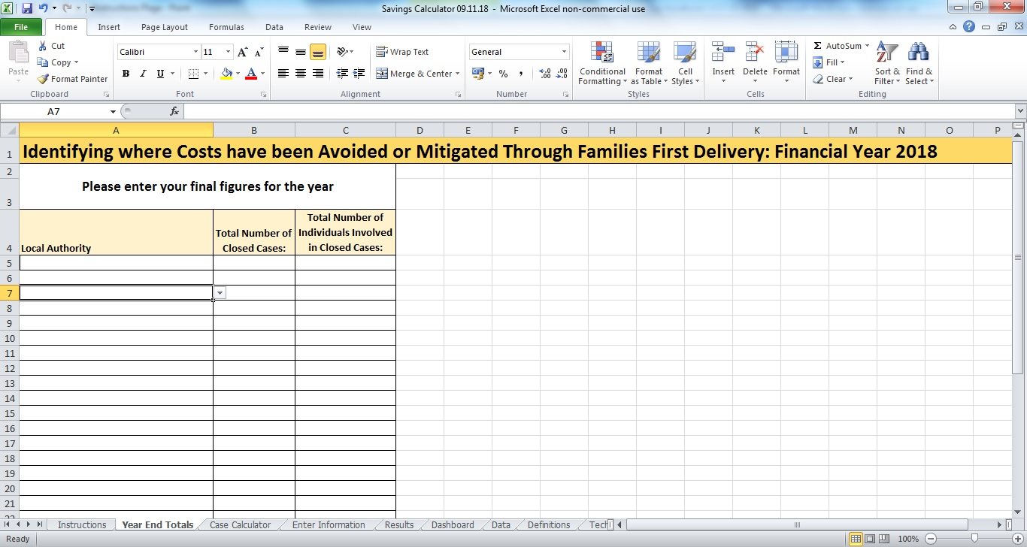

- Select Clean Row for Data Entry.
- Select Local Authority in Column A from drop down menu.
- Enter Number of Closed Cases in Column B.
- Enter Total Number of Individuals.

Now go to Step 2.

Collating Numbers – Step 2
Using the template at Table 3.2 will provide you with the totals for data entry against each of the cells. Definitions for the categories of costs can be found on the Definitions worksheet.

You should have a series of figures that need to be entered into the Cost Calculator worksheet as shown in Figure 4.2 below.

Figure 4.2: Using the Case Calculator Worksheet

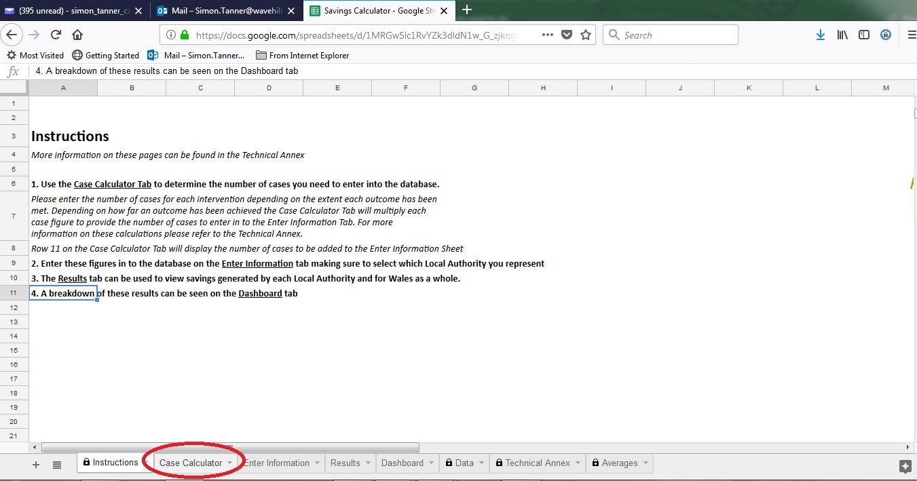

Now move to Step 3.

Entering Data – Step 3
Figure 4.3 provides a screenshot of the Case Calculator worksheet that you’ll need to access to complete Step 3.

It shows that:

- Data is entered against each column in rows 3 (Achieved), 4 (Progress), and 5 (Referred) starting in column B

- Data entry is completed down each column before moving across to the next column the column B (Anti-Social Behaviour), column C (Domestic Violence) etc

- As data is entered, the total cases across rows 3-5 is calculated in row 6.

Figure 4.3: Case Calculator Worksheet for Data Entry

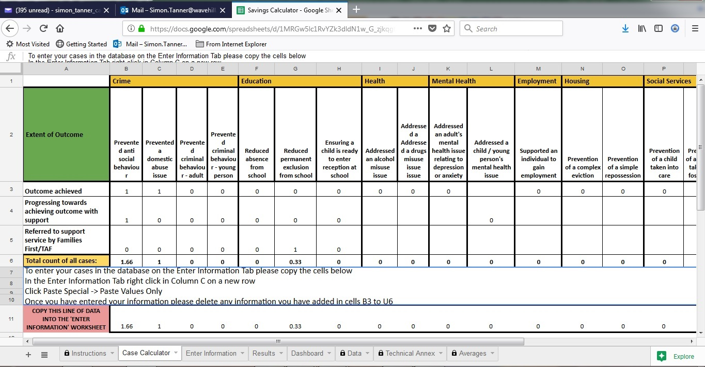

Total counts are calculated in Row 6 which is copied automatically into Row 11 for entry into toolkit.
Step 3
Enter data in each column moving down for each data item.

Now go to Step 4.

Copying Entered Data – Step 4
When all the data is entered you need to complete Step 4.

To complete Step 4, select and copy the data cells in Row 11 ready to paste into the ‘Enter Information’ worksheet – see Figure 4.4.

Figure 4.4: Copying Data for Data Entry

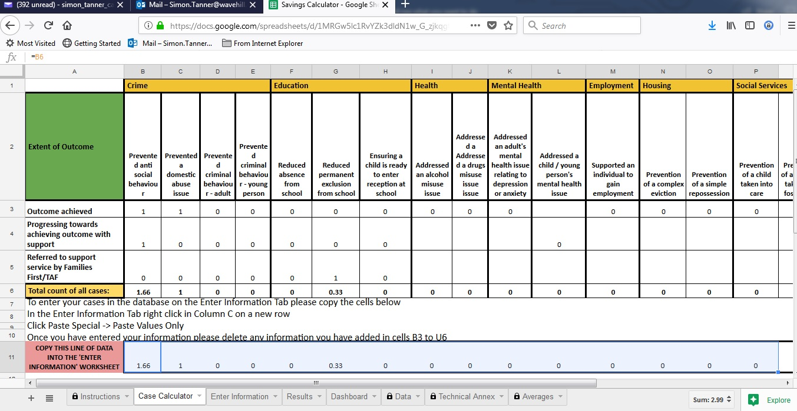

Once copied, click on the ‘Enter Information’ worksheet.

You are now ready to begin pasting the copied data into the worksheet – see Step 5 overleaf.

Classifying Data – Step 5
Figure 4.5 shows where to paste the entered data into the toolkit, through the ‘enter information’ worksheet as shown below.

Before doing that we need to provide a date of data entry (Step 5a) and identify the local authority the information comes from (Step 5b)/

Figure 4.5: Entering Information into the Toolkit

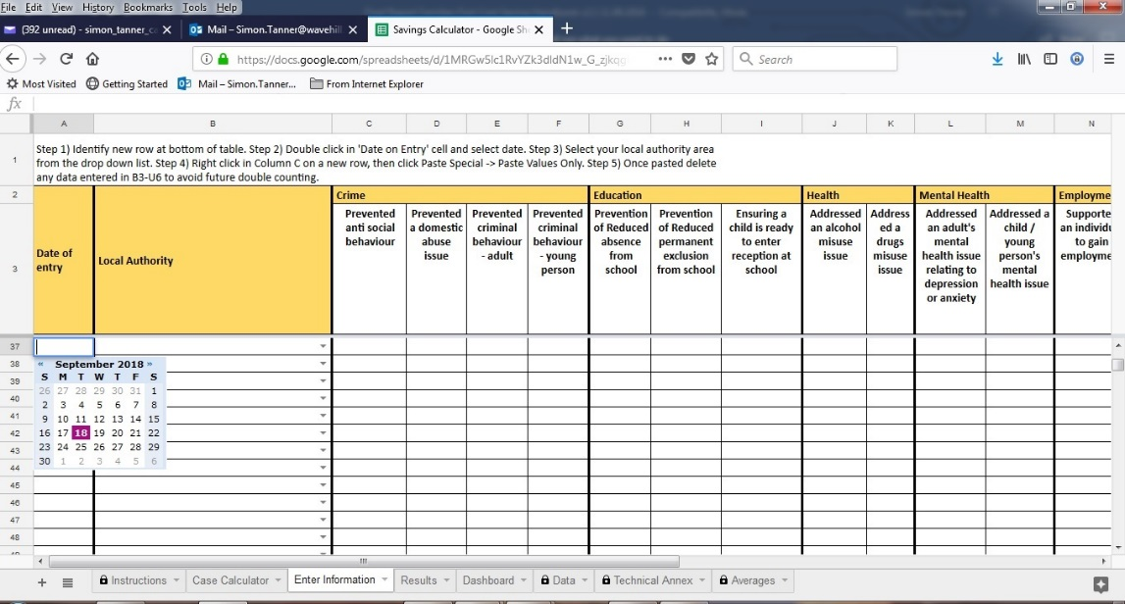
Step 5b
Then use drop down menu in column B to select your local authority.
Step 5a
Select ‘clean’ row of data. Enter date in column A in DD/MM/YYYY format.

You are now ready to paste your data into the toolkit – see Step 6 overleaf.

Pasting Data – Step 6
Figure 4.6: Pasting Data into Toolkit

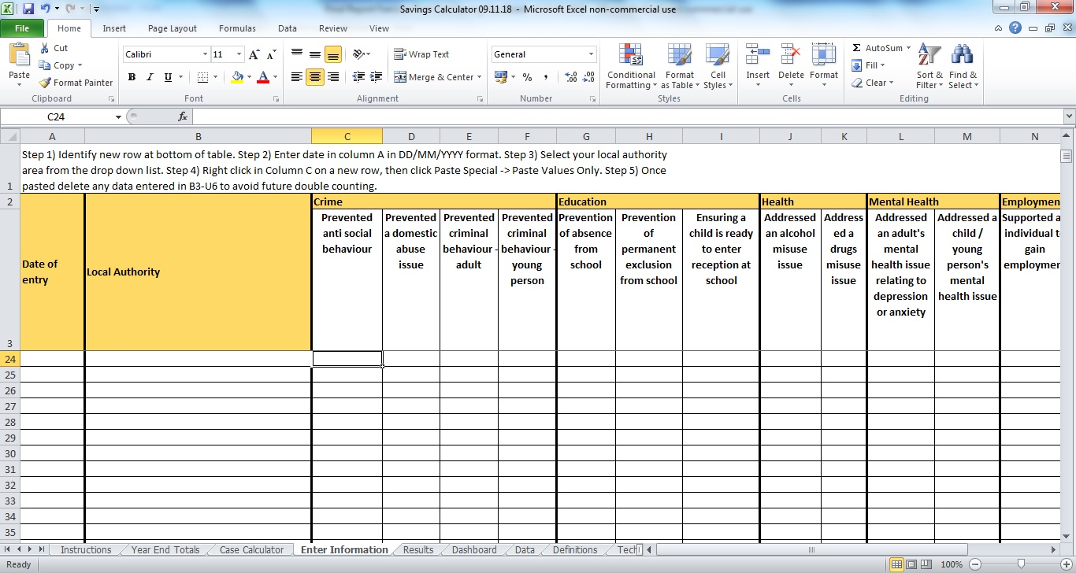
In column C right click in the relevant cell and select ‘Paste special’, ‘Paste values’.

Reviewing Results
Figure 4.7: Results Produced

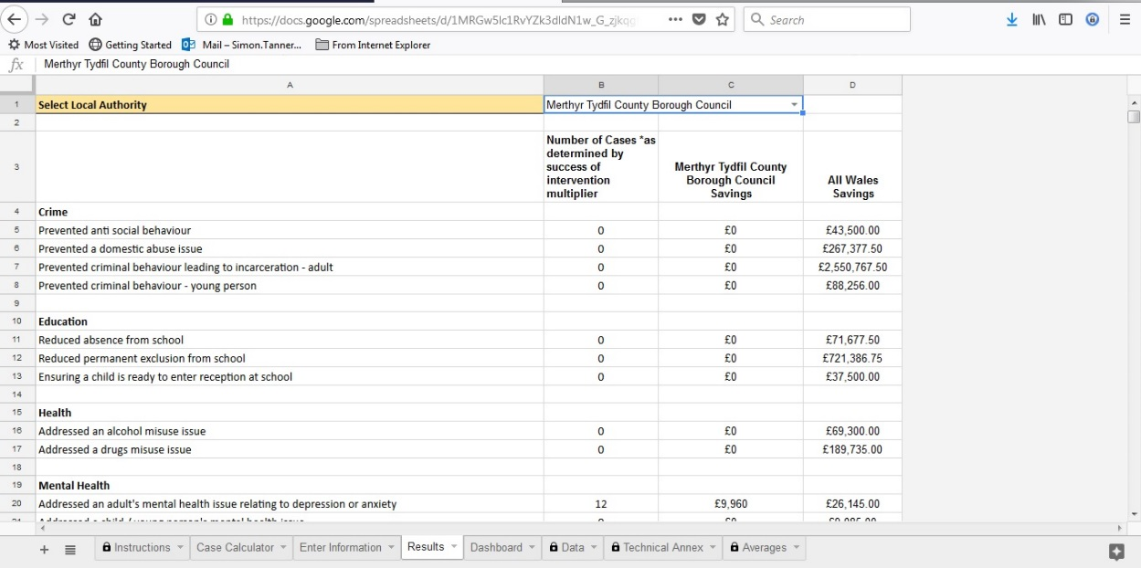

Select your relevant local authority from drop down box here to show specific results with All Wales comparison to the right.

Further Support
For further help on the use of the Toolkit contact:

Paula Gallagher / Simon Tanner at Wavehill
Tel: 01545 571 711
Email: paula.gallagher@wavehill.com / simon.tanner@wavehill.com

Note: Authorities may if they wish use the toolkit to capture all closed cases in a relevant financial year.
The Common Assessment Framework applies in England where the New Economy Manchester model has drawn its data from. However, the focus on Proportionate Assessment as advocated by the Social Services and Well-being (Wales) Act is strongly aligned with this and this measure reflects that Families First work can help prevent the need for Proportionate Assessment for some clients.

