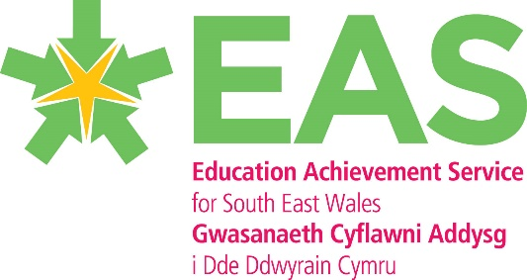 EAS Looked After Children Action Plan 2016/17

This is the EAS regional Action Plan to implement the recommendation from the Estyn Thematic Report (July 2016). These will be the areas from the report that we will develop in the 2016/17 academic year.

Recommendation - Improve how regional consortia plan for the PDG/LAC to make sure that schools are clear on the priorities for the use of the grant and their plans to consider the complex needs for looked after pupils.

Objective/ Estyn Findings | Action | WG action plan Link | Timescale | Who | Monitoring
Develop a pro-active approach to seeking out and sharing best practice in relation to how  schools support children who are looked after and formerly looked after on a regional level | The development of the SEWC LAC steering group to oversee the allocation of the LAC PDG. Part of the role of this group will be to identify and share good practice across authorities. Linking schools up across the region to develop and share their practise.  Develop case studies for PDG funded projects /initiatives with shown impact and outcomes for pupils. Produce an EAS good practise guide for LAC and former LAC pupil’s school’s guide to support the 2017/18 grant process.  Regional event to share and showcase practise.  Link with Principle challenge advisor with responsibility for LAC to develop planning across the region. | AP – 3  AP – 13  AP-14  AP-16  AP-34 | Termly  Spring term 2017  Ongoing | DL/Steering group /LAS and schools | Continuity of approaches across the region  PDG applications to focus on areas of good practise developed. /known initiatives that show impact on pupil outcomes  Schools across the region working together on a S2S basis
Ensure there is a robust tracking system, which is used to support close scrutiny of the  effectiveness of the local authority’s work with schools to improve the attainment,  achievement and ambition of children who are looked after  comprehensive | Further develop the use of the EAS data tracker and LA monitoring systems to better track and monitor outcomes for LAC pupils.  Produce a regional data set for LAC pupils and pupils receiving PDG funding to enable us to track the progress towards targets termly.  target PDG funding to focus on identified areas.  (This is the WG action for the region to develop as part of the NSG work plan) | AP – 8  AP-30  AP-31 | Autumn Term 2016 | DL/EAS Data Intelligence team | Individual targets set by schools  Regional data /test scores  Comparisons of data within region and across wales.
Governing bodies and designated governors for children who are looked after have a  key role to provide suitable challenge to head teachers. | Complete governor training as part of the consortia training package and develop a governor resource to support their role as LAC governor for use across the region. | AP – 8  AP - 10 | Autumn term 2016 | DL/TASG/EAS | Evaluation of training  Use of reporting/monitoring of key performance statistics for LAC
Training for school staff and carers to help them understand and  support the social and emotional needs of children who are looked after | Continue to develop the consortia training programme to provide training and support for a range of stakeholders | AP – 9  AP-10  AP-23 | Ongoing | DL and providers of training plan. | Analysis from training given  Exclusion incidents reduced
Communication of regional priorities and planning EAS – LA – school and other agencies | Shared understanding of regional/local and school priorities –  Communication of Grant to all LA via development of steering group.  Regular updates at HT meetings and steering group to ensure shared practise | AP - 2  AP - 8  AP – 13  AP - 17 | ongoing | DL and EAS | Steering group  LA meetings  Network meetings
Continued links with other regions and joint consortia working | meeting with WG  Joint training events | AP – 1  AP - 9  AP - 8  AP – 12 | ongoing | EAS/CSC/ERW/GWR | WG national meetings  Consortia leads meetings

