**CCG – Ceredigion LA**

This case study aims to demonstrate effective partnership working at a community level, through use of the PPE fund.

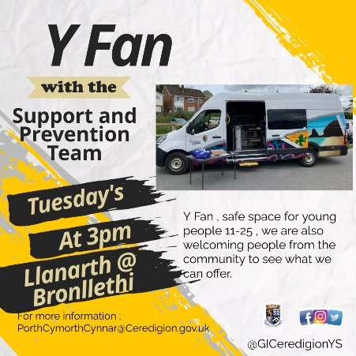In this reporting window, Prevention Youth Workers developed a working relationship with the local policing team and PCSOs through the Mobile Van Project, specifically in the Llanarth area. The Mobile Van Project responded to reports of ASB and the need to develop better community cohesion. The provision visited the area consecutively for a several weeks, to build presence amongst the community.

As a result of this intervention, positive relationships were developed between services and young people and their parents/carers in the area. With this foundation in place, Prevention Youth Workers extended an invite those groups involved, to attend Aberaeron Youth Club, this included the police.

When Police Officers first visited Aberaeron Youth Club, young people would often leave the setting and return once they had left. However, over time and though building rapport, this is no longer an issue and young people instead actively engage with the police in activities and conversation.

Developing this meaningful relationship between young people, Youth Workers and the Police has been hugely beneficial in providing a safe space for young people to meet the Police Officers in a positive and constructive manner, and change their perception of law enforcement, to now see them as a source of support. The provision has also supported community cohesion amongst others, with members of the public viewing young people in a more positive light now that immediate ASB issues have been addressed, with diversionary activities.