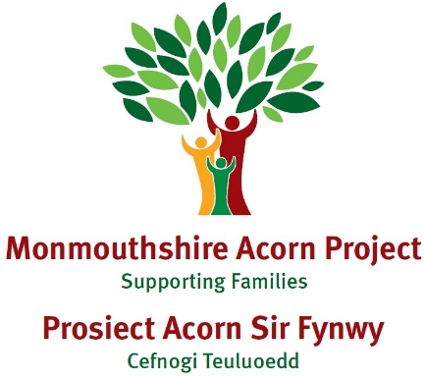

Case Study N

|  |
| --- |
| **Family Make up**  Child – Age 7 and parents, Mum, Dad |
| **Dates involved with Families First - 2023- Feb 24** |
| **Overview of situation when family came to Families First**  Family were referred in for support with parenting and N was struggling with separation anxiety and attending school. N has ill health. |
| **Main issues:**  School Attendance (reduced timetable), N didn’t feel comfortable going to school, Separation Anxiety,  N’s ill health |
| **Services involved:**  Acorns, Monmouthshire Housing, School , School Health Nurse, Education welfare. |
| **Activities/Actions carried out to address**  Bespoke parent support  73 contacts plus meetings, referrals to other agencies and professional conversations with other organisations.  Work focussed on N’s emotions, strategies to support anxieties, routines and healthy eating.    Contact was made with education welfare service to improve school attendance. We also supported N in using the school bus. We accessed support for N’s mother from Mind Monmouthshire. A DTR was submitted to children’s services following a disclosure and the family provided with support on a CASP. We helped embed routines for school, homework and bedtime.    N was identified as overweight by the School Nurse so we strategies for encouraging healthy eating and eating together were explored.    Mum engaged well with our service and would call or text on a regular basis outside of our scheduled appointments if she needed support. |
| **Outcomes**  N attendance became better with her being in school on a regular basis and if she didn’t want to go mum would contact her and we would talk through a plan to get her into school.  N became better at separating from parents. N settled in school and is starting to build relationships with teachers and friends. Mum’s communication and relationship with school improved greatly. N had a better routine and was ready in time to get on the bus to school. As a result of our work, MHA got involved and helped with the housing situation and home conditions have improved. |

Astudiaeth Achos N

|  |
| --- |
| **Gwenuthuriad Teuluol**  Plentyn – 7 oed a rhieni, Mam, Dad |
| **Dyddiadau ar gyfer Teuluoedd yn Gyntaf - 2023 - Chwefror 24** |
| **Trosolwg o'r sefyllfa pan ddaeth teulu i Teuluoedd yn Gyntaf**  Atgyfeiriwyd y teulu i gael cymorth gyda magu plant ac roedd N yn cael trafferth gyda phryder bod ar wahân ac yn mynychu'r ysgol. Mae gan N afiechyd. |
| **Prif faterion:**  Presenoldeb Ysgol (amserlen lai), nid oedd N yn teimlo’n gyfforddus yn mynd i’r ysgol, Pryder Bod Ar Wahân, Afiechyd N |
| **Gwasanaethau dan sylw:**  Acorns, Tai Sir Fynwy, Ysgol , Nyrs Iechyd Ysgol, Lles addysg . |
| **Gweithgareddau/Camau a gyflawnwyd i fynd i'r afael â hwy**  Cefnogaeth rhieni pwrpasol  73 o gysylltiadau ynghyd â chyfarfodydd, cyfeiriadau at asiantaethau eraill a sgyrsiau proffesiynol gyda sefydliadau eraill.  Roedd y gwaith yn canolbwyntio ar emosiynau N, strategaethau i gefnogi pryderon, arferion a bwyta’n iach.    Cysylltwyd â'r gwasanaeth lles addysg i wella presenoldeb yn yr ysgol. Fe wnaethom hefyd gefnogi N i ddefnyddio'r bws ysgol. Cawsom gymorth i fam N gan Mind Sir Fynwy. Cyflwynwyd DTR i’r gwasanaethau plant yn dilyn datgeliad a rhoddwyd cymorth i’r teulu ar Bartneriaeth Diogelwch Cymunedol. Gwnaethom helpu i sefydlu arferion ar gyfer yr ysgol, gwaith cartref ac amser gwely.    Nodwyd bod N yn rhy drwm gan Nyrs yr Ysgol ac felly archwiliwyd strategaethau ar gyfer annog bwyta'n iach a bwyta gyda'n gilydd.    Ymgysylltodd mam yn dda â’n gwasanaeth a byddai’n ffonio neu’n anfon neges destun yn rheolaidd y tu hwnt i’n hapwyntiadau a drefnwyd pe bai angen cymorth arni. |
| **Canlyniadau**  Daeth presenoldeb N yn well gyda’i bod yn yr ysgol yn rheolaidd ac os nad oedd eisiau mynd byddai mam yn cysylltu â hi a byddem yn trafod cynllun i’w chael hi i mewn i’r ysgol.  Daeth N yn well am wahanu oddi wrth ei rhieni. Ymgartrefodd N yn yr ysgol ac mae'n dechrau meithrin perthynas ag athrawon a ffrindiau. Gwellodd cyfathrebu a pherthynas mam â’r ysgol yn fawr. Roedd gan N drefn well ac roedd yn barod mewn pryd i fynd ar y bws i'r ysgol. O ganlyniad i'n gwaith, cymerodd MHA ran a helpodd gyda'r sefyllfa dai ac mae cyflwr y cartref wedi gwella. |