**Families First Case Studies**

**Sparkle**

*Support and activities for children with disabilities and/or developmental delay.*

Child A aged 7 with a diagnosis of ASD & ADHD accesses Saturday play club. Over the last couple of months staff have seen an increase in communication, Child A generally uses an AAC device however, in addition, they have recently started using spoken words (one word level) including names of the LSW’s that support them and also “park” and “toilet” to express their needs/wants.

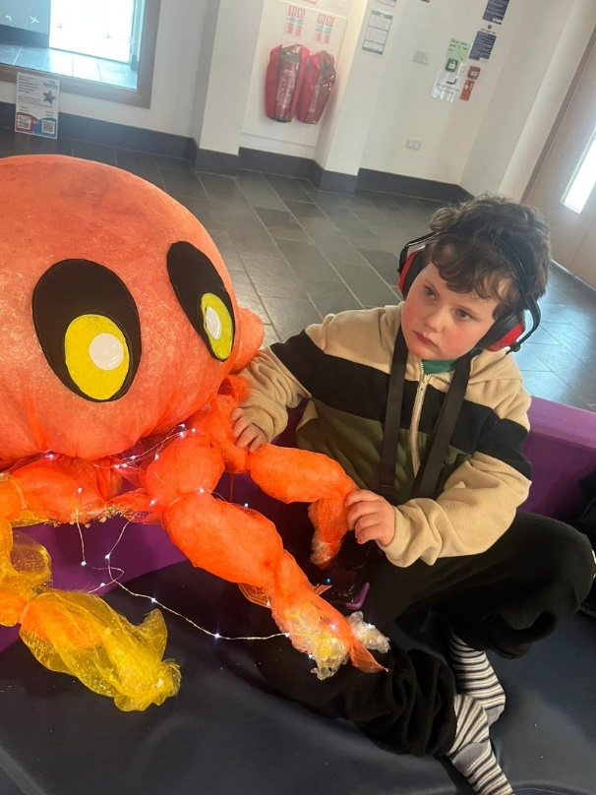Staff are also seeing an increase in confidence and feeling more comfortable within the setting. Previously Child A would not attempt to travel down the corridor to the rebound facility without lots of prompting and slowly moving/against the corridor walls. However, Child A now is happy to move down the corridor (at speed!) to access the rebound trampoline and gym.

Child A requires 2:1 support due to their complex behaviour needs however we are seeing a slight decrease in behaviours which we feel may be due to feeling more settled and the increase in verbal communication.

Parents report that Child A is “always happy and excited to come to play club, he has such a special bond with staff and we know he is well cared for and looked after. We’ve seen an increase in his happiness and confidence, since starting play club”.

Young Person B aged 16 with a diagnosis of ASD, accesses Monday youth club. They initially joined Sparkle to access swimming lessons but as familiarity and rapport with LSWs grew, Young Person B requested to join youth club. Young Person B has been enjoying club and has since joined Sparkle’s Independent Living Skills programme where they have learnt and practised skills managing finances, using public transport (attended a trip to Cardiff using the train), planning and cooking meals, etc. Outside of Sparkle Young Person B has also signed up to complete the Duke of Edinburgh award using their swimming lessons as a skill.

Parent report “since joining Sparkle activities there has been a big change in confidence and independence. In social situations, he is happy to initiate conversation and try new things/go to new places. We are so grateful for the support of staff and their encouragement of my son”.

Child C aged 11 with a diagnosis of Quadriplegic cerebral palsy and visual impairment, accesses Friday play club. Child C requires 1:1 support to assist with their mobility and requires use of a hoist to be lifted in and out of their wheelchair. Child C enjoys being hoisted onto the rebound trampoline and enjoys staff to bounce them. Child C enjoys engaging with their peers and also chatting with staff. Child C is LAC and is currently residing temporarily in a residential home. Apart from school, play club is the only other environment where Child C has the opportunity to engage in a social activity and spend time with their peers.

*“I like Friday club because everybody is lovely there and I like the fact that we get to do what we want within reason (giggles). My favourite is G (Sparkle worker) and I don’t have a favourite friend actually. I like making bracelets and beads and anything”,* Quote from Child C.

Child C’s Residential key worker reports, *“Sparkle is a great opportunity for children to make friends and socialise. Child C loves Friday play club. She looks forward to it all week and doesn’t stop talking about it after she has been”.*

Young person D aged 17 has a diagnosis of ASD, accesses Thursday Youth club. Young person D is non-verbal and requires 1:1 support. Whilst at club, young person D likes to wander around exploring the centre whilst listening to his favourite tunes via a speaker. Young person D loves the climbing wall and staff encourage different challenges by using the coloured holds on the wall, this can help to focus and develop concentration skills.

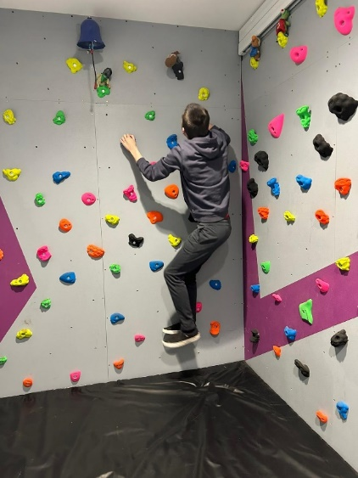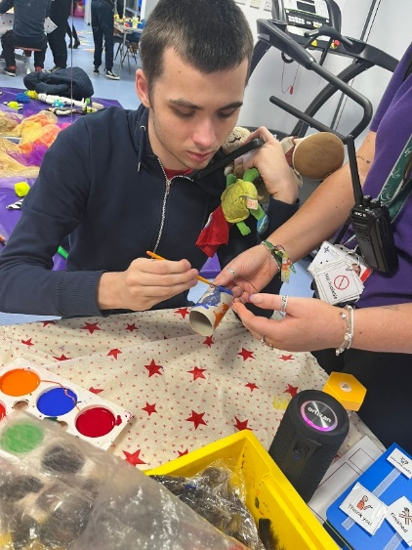Young person D enjoys the outdoor areas, running and jumping on the play equipment, they also like people watching, laughing and smiling at peers whilst they play. Young person D likes an iPad for the last 15 minutes of the session and enjoys sharing their favourite theme tunes or music videos with the staff to dance and sing along to.

*“My son loves Sparkle and going to club and participating in the different experiences and opportunities. The staff have built really good relationship with him, they know my son and I know he is looked after and encouraged to try new things”,* quote from Young person D’s parent.

Child E aged 10 has a diagnosis of ASD, accesses Saturday play club. When Child E initially started in club, they were very unsettled and refused to participate in any activities and would push staff away when trying to interact. However, with consistent and familiar staff members, reassurance and preferred items of comfort available, Child E began to feel more comfortable and relax in club. Child E now shows excitement to come in and enjoys taking part in a variety of activities, they particularly enjoy the sensory room and sensory play.

