Background
F is a15 year old living in the Pill area of Newport having moved to the UK from Romania with his family and relatives approximately five years ago, for the children to receive a good education learn English, and have a better life etc. The family are of Roma heritage.
Engagement
F has regularly attended the open access Pill Friday Night Project for several years. The project is at Pill Millennium Centre which is just around the corner from his house. F chose to come and get involved in the session and enjoys taking part in football in a safe space. Over considerable time and through trusted relationships being formed it was evident that F needed targeted support. His behaviours were becoming more and more challenging, and the team felt he needed intervention due to his vulnerability. Workers offered him time to engage with them separately from the session and he accepted and attended regularly.
Challenges
As workers began to see more of F’s life, it was clear there was extreme poverty in the family. The house was extremely overcrowded, siblings looked after younger family members and sometimes missed school. Health access was poor with F’s parents not speaking English and not getting the help they needed. Dad was picking up work from car washes where he was potentially being exploited. Workers were worried about F, who he was associating with and how he felt he needed to behave to be accepted here. School attendance was reducing with aggressive outbursts happening.
It was clear the family were at risk of exploitation due to their lack of knowledge of the UK support systems and trusting services to help. F was becoming a young carer, trying to keep the family together and supported which was too much to deal with as a child within the family. He was relied on for translation and often dealing with financial worries that a child shouldn’t have to be exposed to. F’s way of coping with the stress and anxiety was to smoke cannabis. We were hopeful that by supporting him and giving him time, he would understand how that will make his anxiety worse in the long run.
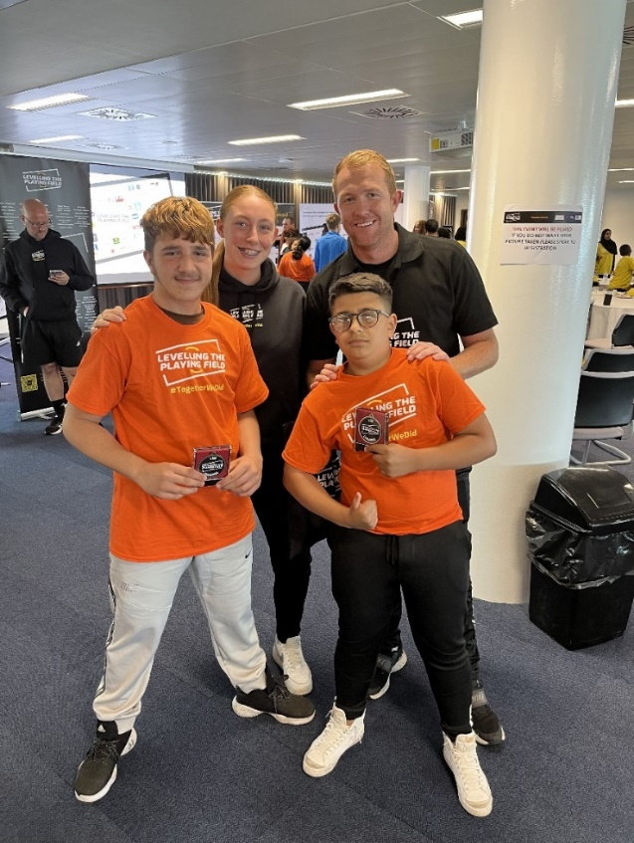
Multi agency approach
After unearthing a number of issues, it became clear a multi-agency network was needed to help with the multiple layers of complexity in the family. Due to a relationship being established with the family, it was timely to introduce a Preventions worker to help with the needs of the parents and the household.
A joint visit with Positive Futures and Preventions took place and the parents were encouraged to share their biggest worries and concerns. The parents did open up allowing the Preventions worker to give them the correct advice, contacts and support for their needs. This has resulted in attending appointments with them and following up and pushing agencies to get back to the family and help them. The Preventions worker involved the NCC Cost of Living team as well to enable additional support to be offered with transport and access to the internet.
Learning
We are stronger together! Positive Futures cannot meet all the needs of the family when working with the young person. We have built a trusted relationship over time resulting in making it easier for other services to get into the family home and see what is going on. The Preventions worker understood how difficult it was for the family and had a flexible, non-judgemental approach.
Outcomes
The family have been helped before reaching further crisis and potential criminal exploitation. This has reduced the chances of the family coming in for support, such as SPACE Wellbeing, and put more pressure on waiting lists.
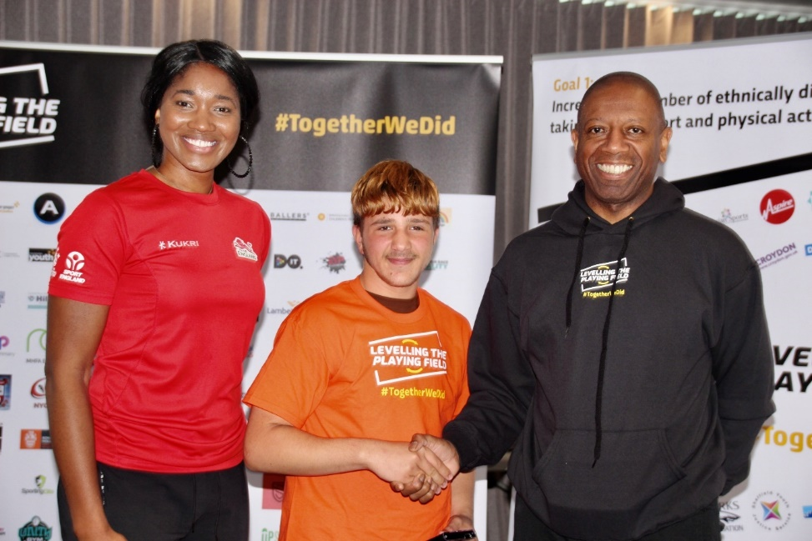
This family and the approach taken is a good example that the PPEYP delivery model is working and will continue to do so.
Next steps
F continues to engage in the community offer, he seeks out to speak to staff when he needs them. He has attended events through the summer and has volunteered, helping staff to engage with children and young people in the community.

