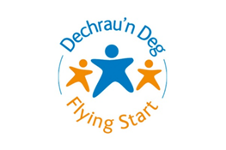**SLT Community Nursery Nurse**

**Case study**

The child was seen in the home by the Flying Start Speech and Language Therapist for an initial appointment following a referral from the Health Visitor. The outcome from the initial appointment was a delegated block of support with the SLT Community Nursery Nurse in the home.

The child lives at home with both parents and older siblings. The child has recently turned two years old. The child has been having regular weekly sessions to support her communication and Makaton signing has been introduced to aid with her expressive communication. The child is making good progress and the mother is very supportive in encouraging Makaton signing and has been practicing every day. We have now decided to conduct the last few sessions every other week. Mother reports that the child is starting preschool at the end of the month and would appreciate a visit to communicate with staff and update on communication targets. The child was recently admitted to hospital, Mother reported that the child communicated with the hospital staff using Makaton sign. She signed ‘food’ confidently to tell the staff that she was hungry. Mother also reported that the older sibling had visitors at their school who used Makaton sign. The older sibling was able to understand the Makaton signs being used by the visitors and was able to explain their meaning to her classmates as she uses signing daily with her sister. Mother is happy with the child’s progress and is seeing lots of improvement in her child’s communication. Mother is happy with the support and is reassured about her child starting preschool at the end of this month.