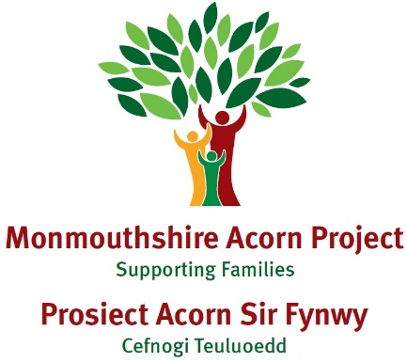

Case Study H

|  |
| --- |
| **Family Make up**  Child – 7 years old  Sibling – 4 years old  Mum, Dad |
| **Dates involved with Families First**  **May – October 2024** |
| **Overview of situation when family came to Families First**  Parents had previously completed a Circle of Security parenting course with Acorn Project and had accessed support through Building Strong Families. Parents emailed the SPACE wellbeing team following these interventions as their daughter (H) was continuing to struggle with sleep. They were signposted to Acorn Project for further support. H was struggling to get to sleep and was waking in the night. Parents also reported that H was quite argumentative when she awoke. Parents did not know how to help H and were feeling very frustrated. |
| **Main issues:**  Sleep |
| **Services involved:**  None at time of referral |
| **Activities/Actions carried out to address**  An Acorn Project Parent Advisor was allocated to the family to provide a bespoke package of support which consisted of 7 sessions:   * Bedtime routine * Quality time * Movement * Emotions and anxieties * Being with * Connections and separation * Sleep strategies (especially when away from the family home)     In addition to this support there was some ad hoc telephone follow up support to check in on the family to see how things were going. |
| **Outcomes**  On closure, parents reported that H was sleeping through the night and was going to sleep well  Parents reported an improvement in their ability to support their child  Parent reported an improvement in their relationship with their child  Parents reported an improvement in their own wellbeing |