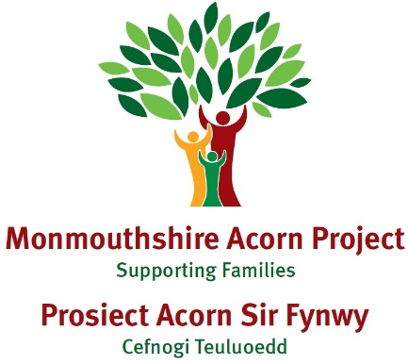

Case Study E

|  |
| --- |
| **Family Make up**  Child E – 9 years old  Mum and Dad (shared 50/50 custody) |
| **Dates involved with Families First**  January – October 2024 |
| **Overview of situation when family came to Families First**  Referral from SPACE Wellbeing from GP for support with behaviour. |
| **Main issues:**  Mum reported issues with:  Sleep  Hitting/biting/throwing objects  Abusive language  Obsessive behaviours |
| **Services involved:**  Educational Psychologist  School |
| **Activities/Actions carried out to address**  **8 Circle of Security Sessions**  **14 1-1 sessions**  An Acorn Project Parent Advisor was allocated to the family. Mum attended and completed the Circle of Security parent programme. During the sessions, mum was very emotional and was struggling with E’s behaviour at home, so it was agreed that a Parent Advisor would provide some additional bespoke support outside of the group.  The Parent Advisor coordinated meetings between the parents, the School, and the Educational Psychologist. The Educational Psychologist observed E in class, met with the parents, and arranged a follow-up meeting accompanied by the Parent Advisor focusing on emotional coaching.    Dad was offered the Circle of Security programme, but he declined. As the maternal grandfather supports mum a lot with E, he was offered and completed the Circle of Security Programme.    Mum shared that her mum passed away when E was a week old, which deeply affected her. The Parent Advisor discussed counselling, which Mum had accessed before and was willing to revisit through her work.    Mum discussed her past experiences with domestic abuse from her ex-partner. The Parent Advisor recommended contacting Cyfannol (Women’s Aid) for support. Additionally, we talked about support for E, and the Parent Advisor referred E to the STAR Project.  Following this, Mum's outlook on the situation improved, resulting in less frequent support. Both the Parent Advisor and Mum began to consider a gradual closure to ensure the process was not abrupt. |
| **Aligning to NEST/NYTH Principles**  **Trusted Adults –** Acorn Project aims to empower parents/carers to effectively support their children’s emotions and wellbeing.  **Wellbeing across education –** Acorn Project works with schools to ensure wellbeing support for families.  **Co-produced innovations –** Acorn Project looks at ‘What Matters’ most to the family as a starting point and works with other services to provide the most effective and timely support.  **Easy access to expertise –** Acorn Projectsits on the SPACE Wellbeing panel and liaises with many other services rather than having to refer or signpost parents/carers to other services. Our Parent Advisors are key workers and try to co-ordinate the right support.  **Safe and supportive communities –** Acorn Projecthelps families think about their strengths, support networks and access to local services that will help support health and wellbeing.  **No wrong door –** Acorn Project puts ‘what matters to the family’ at the forefront of any interventions. Other services may be needed to support along the way and the Project uses a ‘team around the family’ approach to ensure support is given by the right service at the right time. |
| **Outcomes**  On closure, parent reported an improvement in confidence in ability to support E.  Mum reported an improvement in her relationship with E.  Mum reported an improvement in her own wellbeing  Mum’s feedback:  “Parent Advisor ‘A’ helped me with caring for my son both at home and with meetings in school. She also helped me with what was needed to send off his ADHD assessment. Possibly life changing for myself and my son. We are able to get through our days so much better now and situations are so much less scary for us both.” |