
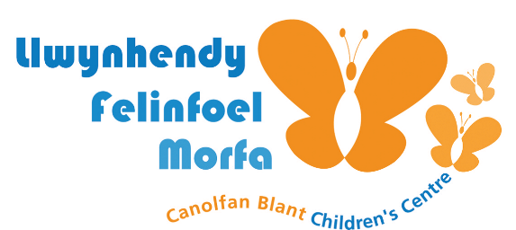

T is an 11-year-old girl who began attending Open Access Play sessions in our Children’s Centre after-school and during school holidays. She lives locally and was initially quiet and hesitant to join in with group activities.
Early Engagement
- T preferred solitary play and often observed others from a distance.
- She was curious but unsure about trying new activities.
- Staff noticed she responded well to gentle encouragement and creative play.
Supportive Environment
Open Access Play provided:
- A welcoming, inclusive space where children could choose how they played.
- Freedom and flexibility to explore different types of play (creative, physical, imaginative).
- Supportive adults who built positive relationships through consistent presence and encouragement.
Positive Changes Observed
Over time, T:
- Began joining group games like Uno and den building.
- Took part in arts and crafts, proudly sharing her creations with staff and peers.
- Developed confidence in expressing her ideas and trying new things.
- Formed friendships and started helping younger children with activities.
Benefits of Open Access Play for T
- Increased confidence and self-esteem.
- Improved social skills and peer relationships.
- Creative expression through art, role play, and storytelling.
- Physical activity and healthy risk-taking in outdoor play.
- Sense of belonging and emotional wellbeing.
Staff Reflections
“T has really come out of her shell. She’s gone from watching quietly to leading games and helping others. It’s lovely to see her smile and feel proud of herself.”

Parent Reflections:
“Her confidence has grown loads and we’ve built trust by doing little things like allowing her to go to club and to the shop on her own. She absolutely loves coming and wants to be a mentor when she’s too old to come to club.”

