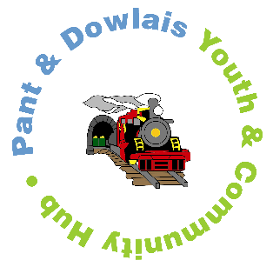
The Pant and Dowlais Boys and Girls Club (Engine House)
~CASE STUDY~

PROJECT TITLE | Bullying Awareness workshop

AIM: The aim of the Bullying awareness workshop was to raise awareness and understanding of bulling among young people, helping them to recognise its different forms and develop strategies to promote kindness, respect, and positive relationships. The project aimed to create a safe supportive space where young people could explore this topic through the five pillars of youth work.

OBJECTIVES: To Provide an educative experience that increased young people’s knowledge and understanding of bullying, its impact, and how to seek support. To promote participation through group discussions, role play, and team-based problem solving. To empower young people to speak out against bullying and support their peers in creating a respectful environment. To ensure the programme was inclusive, giving every participant an equal voice and opportunity to share their experiences, also to offer and expressive platform where young people could reflect on their feelings and communicate them creatively through writing and art.

HOW WAS THE NEED IDENTIFIED? The need for this workshop was identified through youth worker observations and conversations with young people, who reported witnessing or experiencing unkind behaviour both in school and online. Following discussions with our team it was recognised that the focused project starts at the new school year which could help young people develop resilience, confidence, and empathy as they returned to school.
HOW WAS THE PROJECT DELIVERED? The bullying awareness workshop was delivered over one week, coinciding with the start of the new school term. Each day focused on a different theme such as understanding bullying, empathy building, online safety, and positive friendship skills. Delivery reflected the five pillars of youth work
Workshops were facilitated by trained youth workers, supported by volunteers, and linked closely to wellbeing initiatives.
WHEN WAS THE PROJECT DELIVERED?
The project was delivered from Monday September 8th to Friday 12th September, as the young people returned to school after the summer holidays. This timing allowed the sessions to reinforce positive behaviour, promote understanding, and set a respectful tone for the academic year ahead.
WHO WAS THE PROJECT DELIVERED TOO?
The project engaged with 25 young people. The group included participants with a range of social and emotional needs, youth workers ensured that the environment remained safe, supportive, and confidential for all.

EVIDENCE: Youth workers observations recorded high engagement and positive participation throughout the week.
Posters, group pledges and reflective journals provided evidence of learning, whilst pre and post workshop surveys showed an increase in confidence in recognising and responding to bullying situations and attendance remained consistent across all sections, showing strong interest in commitment.

YOUNG PEOPLES EVALUATION OF PROJECT:
Feedback from the young people was highly positive. Many expressed that the workshop helped them understand how words and actions can affect others, and that they now felt more confident speaking up or supporting someone being bullied.
Young people also suggested running similar sessions later in the school year to keep awareness strong and support continued learning.

