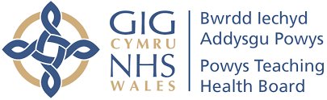 | 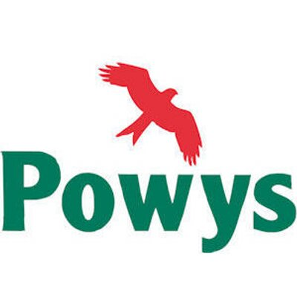

Partnership Agreement

Safe Accommodation for Children with Complex Needs

PURPOSE:
The purpose of this Partnership Agreement is to summarise and document the partnership arrangements, partnership fund management and processes previously agreed between PtHB and PCC for the development, implementation and ongoing delivery of Safe Accommodation for Children and Young People with Complex Needs provision in Powys.

The Partnership Agreement replaces the need for a Section 33 arrangement.

Powys Regional Partnership Board (RPB) successfully secured £525,000.00 capital funding from Welsh Government (WG) to purchase a property to develop Safe Accommodation for Children and Young People with Complex Needs in Powys. The purchase of the property has been completed, work to make the necessary adaptations to the home to comply with the conditions of the planning approval and to meet the requirements for registration with Care Inspectorate Wales (CIW) has been completed. Further HCF capital funding of £55,000 was secured in order to complete and undertake additional works. CIW registration has been approved and two young people have moved into the provision.

Partners were invited to bid to WG for additional revenue funding to develop and implement a model of care to support children with complex needs and open a Safe Accommodation residential home in Powys. Original Revenue Bid was submitted in August, 2020. Revised Revenue Bid submitted for £821,042 and approved late 2022.

A dedicated Project Board was formed for partners to develop, cost and secure agreement for the development and to access one-off revenue funding made available by WG.

As previously reported to the Joint Partnership Board (JPB) and Safe Accommodation Project Board, agreement has been reached in the following areas:

- Joint Proposal
Agreement that the Safer Accommodation project was part of a strategic approach to developing a range of service options for Children and Young People (CYP) with behavioural / mental health issues in Powys.

Individuals running the service would be accountable through the regulator, Care Inspectorate Wales.

PCC will be accountable for all aspects of care using a trauma informed model of practice. PtHB would be accountable for providing psychology and therapy services and would deliver all necessary training on trauma-informed care.

- Client Group
PCC and PTHB have developed a safe accommodation residential provision, which is intended to address the needs of children displaying behaviours where they are a risk to themselves and/or others; who may have experienced significant trauma; who may have substance misuse issues, who will likely be in crisis and who have likely experienced multiple residential placement disruptions. It will be targeted at Powys Children and Young People who are at the highest end of the continuum of need who may have acute or complex social, emotional, mental health and/or behavioural issues.

The model of care will provide clear pathways to community-based care and avoid unnecessary admissions to inpatient care and secure accommodation and provide a step-down solution. The ultimate aim would be to prevent the need for Powys Children to require secure care and will be used as a provision for step down to secure care in the first instance. The provision would be for Powys Children and Young People only.

- Operating Model
Admissions will be agreed through a Multi-Agency Admissions Panel. Crisis admissions will not form part of the model, matching of children placed will be essential to the homes success and this service would not be a provider of last resort.

The provision will be delivered in-house, run by PCC and it is recognised that the ultimate decision on admission will rest with the Responsible Individual. Admissions will be planned in the first instance.

- Risk Management
A Risk Register has been established and an explicit agreement on risk appetite will be developed to inform the operational delivery of the service, including managing violent behaviour in a therapeutic environment.

A quality management system has been developed, with clear measures to inform quality improvement and better outcomes.

The proposed care staffing ratio is planned at 2-1 during the day and 1-1 staff ratio at night, though it was acknowledged that this was subject to adaptation depending on the progress of the young person and the phasing of the admissions.

Evaluation and review has been built into the initial phase of delivery of the service to refine the model.

- Sustainability
The WG revenue funding bid was for one year and plans for return on investment for PCC will be based on avoiding high-cost, out of County Placements and returning children as close to home.

- Finance
PtHB would fund all therapy and psychological care, PtHB will provide 0.4FTE Psychological and 0.6FTE Therapist input. All other posts within the residential care home structure will be funded and hosted by PCC.

RECOMMENDATION:
It is recommended that representatives of PCC and PtHB on Multi-Agency Safe Accommodation Project Board endorse the above Partnership Agreement.

