
Blaenau Gwent Early Intervention Family Support Case Study – Flying Start
Date | 08.04.26
Author | Emma Yendle
Who was the Lead Programme? | Flying Start
Family Composition | Mum, Dad and three children under the age of five years old.
Referral Source | Health Visitor
Description of support provided – how much? | The family initially presented as difficult to engage. Both parents had experienced multiple Adverse Childhood Experiences (ACEs), and the mother in particular expressed a strong mistrust of schools and professionals more broadly. As a result, the family had historically avoided engagement with services.  Initial contact was made by offering the mother the opportunity to attend a Cooking on a Budget programme delivered at the community hub. This intervention was selected as a low-level, strengths-based approach to begin building rapport. The programme was originally planned to run for four sessions; however, due to the mother’s positive feedback and increased engagement, a further two sessions were offered. During this time, the mother formed a positive peer relationship with another attendee, helping to further reduce her sense of isolation.  Following completion of the cooking sessions, participants were consulted about further support they would find beneficial. All parents expressed an interest in a parenting programme, including the previously hard-to-reach mother. In response, a parenting programme was delivered, and the mother began attending weekly sessions consistently. She also began accessing the hub independently to seek additional advice and support, indicating that trust had been successfully established. Although engagement had improved, the mother remained guarded and frequently spoke negatively about her children. Despite receiving guidance on positive behaviour management strategies, it was evident that her parenting approach was heavily influenced by her own childhood experiences, and that alternative strategies were unfamiliar to her.  As the parenting programme drew to a close, consideration was given to maintaining engagement and deepening reflective understanding. An ACEs awareness course was therefore introduced, informed by disclosures the mother had made about her upbringing, which she perceived as “normal” but was likely traumatic. The mother agreed to participate, having developed a sense of safety and connection within the hub environment.  A significant shift occurred during the ACEs programme. During a session exploring intergenerational patterns of behaviour, the mother requested to speak privately following an emotive video. In this discussion, she became highly emotional and disclosed her realisation that her own behaviours were negatively impacting her children. She expressed concern about frequent angry outbursts within the home and disclosed serious mental health difficulties, including previous suicide attempts while caring for the children.  This disclosure was handled sensitively, with reassurance provided that speaking openly was a positive step toward receiving appropriate support. The father also attended the hub and shared aspects of his own childhood trauma. With parental consent and due regard to safeguarding responsibilities, referrals were made to both Social Services and Mental Health services, and a multi-agency approach was established to support the family.  Following completion of the ACEs programme, work continued with a focus on confidence-building and reinforcing positive parenting practices. Intensive support was provided over a period of almost two years, through tailored programmes and individual sessions designed to enhance parental self-esteem, emotional regulation, and parenting capacity.  Over a period of just over two years, the family achieved substantial and sustained positive change. This transformation was reflected not only in improved parenting capacity and emotional wellbeing, but in strengthened family relationships, increased resilience, and improved life outcomes for both parents and children.
Other Agencies Involved? | Multiply – Pathways in Blaenau Gwent
What worked well (Family Support Worker Support) | It was essential to establish trust with the family, and I recognised that the mother had an interest in cooking. I developed a structured cooking programme in advance, and the mother participated as anticipated.
Any problems or challenges | There were numerous challenges throughout the process, particularly regarding Mum's reluctance to express her emotions. Additionally, it proved difficult to observe Mum displaying negativity towards the children; at times, it appeared that she was not fully engaging with the situation, which raised concerns about the potential for positive change.
Outcome of Family Support Worker Intervention | By establishing a strong relationship with the family, I was able to collaborate effectively and provide practical strategies that contributed positively to their daily life. Although the process of supporting the family to implement necessary changes spanned nearly two years, it ultimately allowed them to achieve long-lasting and sustainable improvements.
Outcome of family intervention | Progress was gradual; however, meaningful change became increasingly evident. After approximately one year, improvements were observed in parenting approaches, family relationships, and emotional wellbeing. The children appeared more settled and content, and both parents demonstrated increased motivation to provide positive life experiences that they themselves had not had access to during childhood. As the family approached the end of available Flying Start interventions, alternative progression opportunities were explored. The Multiply programme was identified, and the mother and her peers were encouraged to attend. Despite initial hesitation regarding new facilitators, the mother agreed after reassurance and initial supported attendance. Engagement with Multiply further strengthened the mother’s confidence and independence.  When the youngest child turned four, the family exited the caseload; however, the mother continued to engage successfully with Multiply. At a later date, both parents were invited to attend a focus group regarding behaviour in school settings. The parents shared significant positive updates, including that both were now in full time employment. The father had trained as a support worker for children and young people, and the mother had secured employment in retail during school hours. Both Parents had also passed their driving test and the family now had their own car. During the focus group session, the mother demonstrated warm, positive parenting strategies when interacting with her children. She spoke about them positively and displayed visible pride and enjoyment while observing them play.  Parents today are increasingly aware of the significance of positive parenting, recognising how their actions, attitudes, and choices directly influence their children’s development, future opportunities, and overall well-being. This heightened understanding has led the parents to adopt new approaches to raising their children, moving away from entrenched negative parenting and embracing more nurturing, supportive, and constructive techniques. By actively seeking ways to improve their parenting skills, parents are not only striving to provide a better life for their children but also working towards achieving improved outcomes for the entire family. Such efforts often include engaging in educational activities, fostering open communication, and creating a safe and encouraging home environment, all of which contribute to the long-term success and happiness of their children.
Baseline Assessment Tool Outcomes | 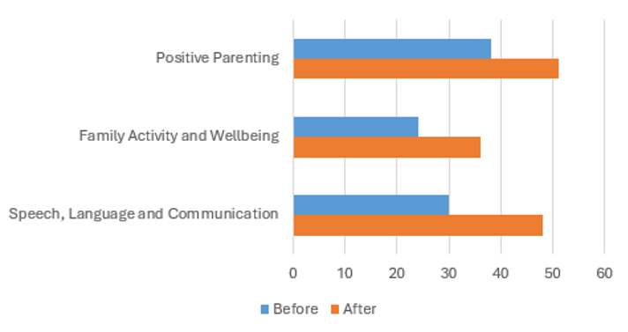
Quote from Family | During the focus session, the mother expressed that without the support and belief from Flying Start, she would still face challenges with her confidence and parenting skills. She indicated her enduring gratitude to Flying Start for positively impacting her life and preventing her children from experiencing Adverse Childhood Experiences (ACEs). The mother reported that the ACEs sessions were highly thought-provoking, providing her with motivation to pursue improvements and adapt her parenting style that has led to better outcomes for her children and family.

